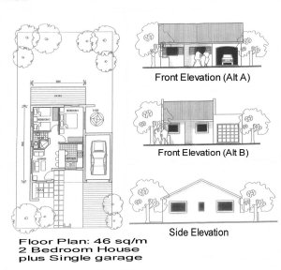 | A 46 sq/m two bed roomed home with BICs. One bathroom, lounge and open plan kitchen. A single garage which is optional. Selling from R370 700.00.Monthly repayment -+-R3229.00. | 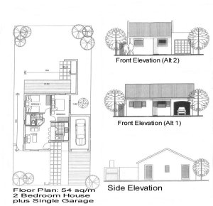 | A 54 sq/m two bed roomed home with BICs. One bathroom, lounge and open plan kitchen. A single garage which is optional. Selling fromR400 300.00. Monthly repayment -+-R3487.00.
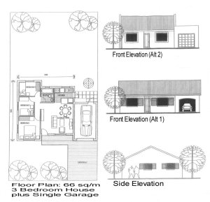 | A 66 sq/m three bed roomed home with BICs. One bathroom, lounge and open plan kitchen. A single garage which is optional. Selling from R444 700.00.Monthly repayment -R3873.00. | 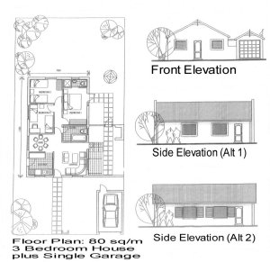 | A 80 sq/m three bed roomed home with BICs. Two bathroom, lounge and open plan kitchen. A single garage which is optional. Selling from R496 500.00. Monthly repayment -R4325.00.
The rand values quoted above are estimated values given at the time of the publishing of this site. A firm value will be established at the time of your purchase. BICs = Built in Cupboards.

